=====================================VMware integration=========================================

If you get a communication error even though the data provided is correct, it might be because of your network/proxy settings on AG. You revise the network/proxy settings when adding a new VMware integration.

reference document : <https://docs.dynatrace.com/docs/platform-modules/infrastructure-monitoring/vmware-vsphere-monitoring>

 step 1)   
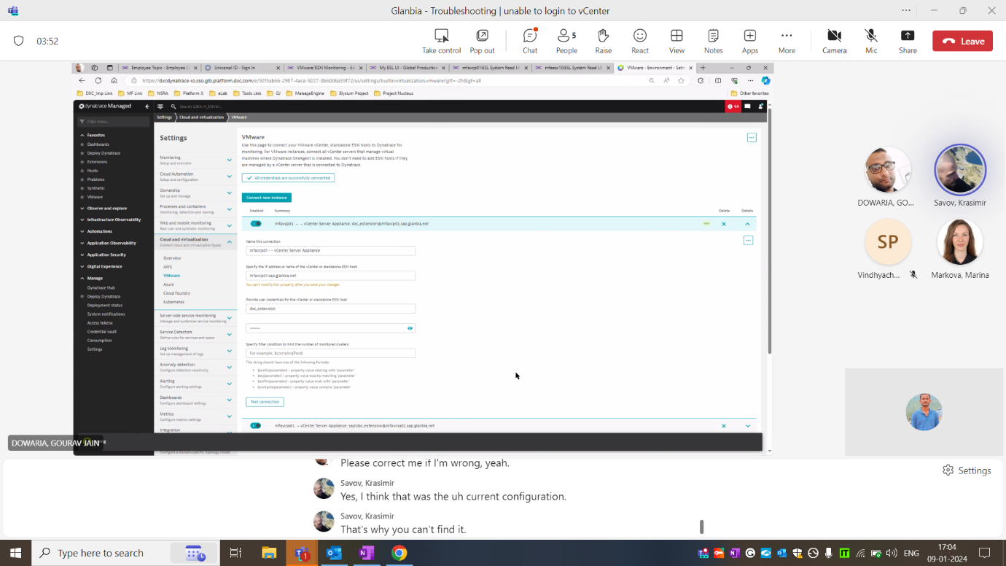

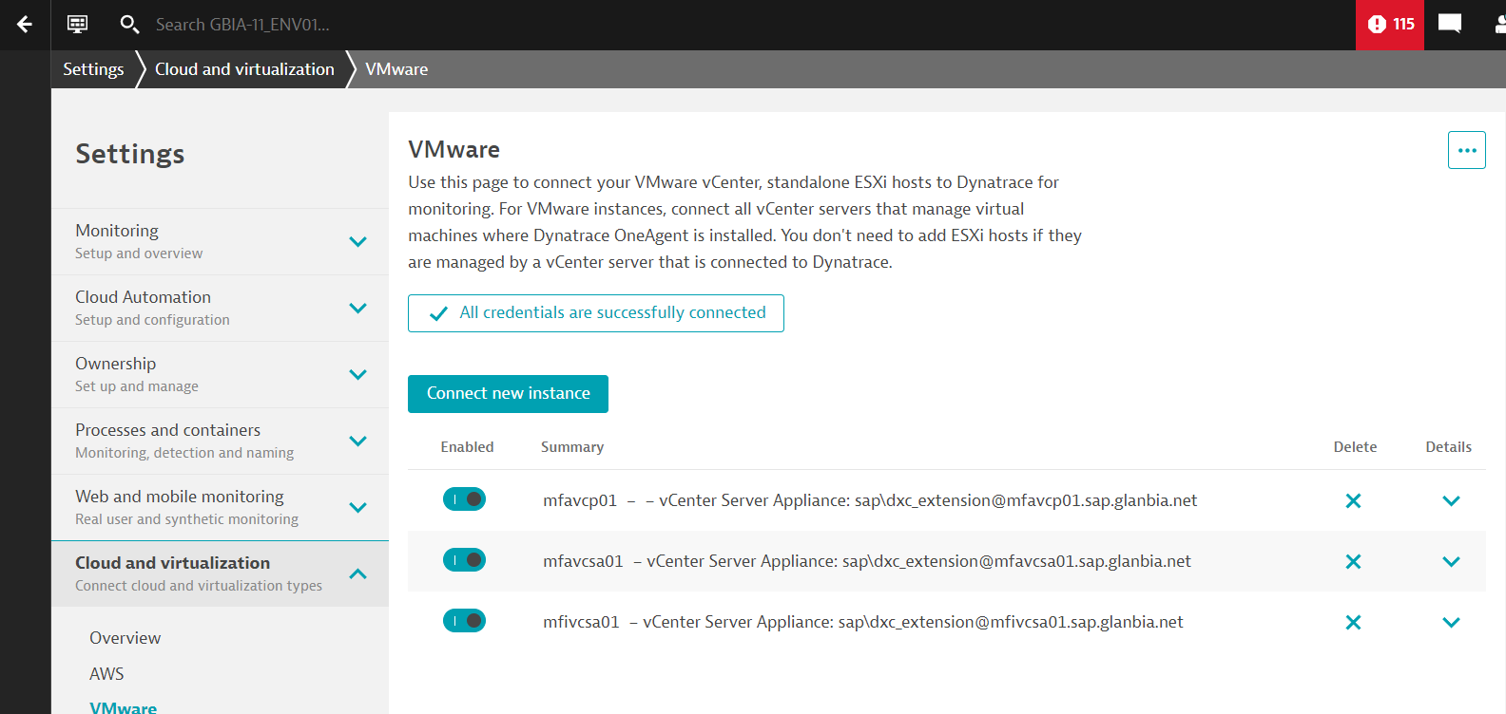

step 2) connect to AG server. then

vi /dynatrace/lib/gateway/config/custom.properties

# Add the list of hosts for communication with which proxy should not be used by ActiveGate.

proxy-non-proxy-hosts = XXXXXXX.sap.glanbia.net | YYYYYYY.sap.glanbia.net

systemctl restart dynatracegateway

=========================================================================================